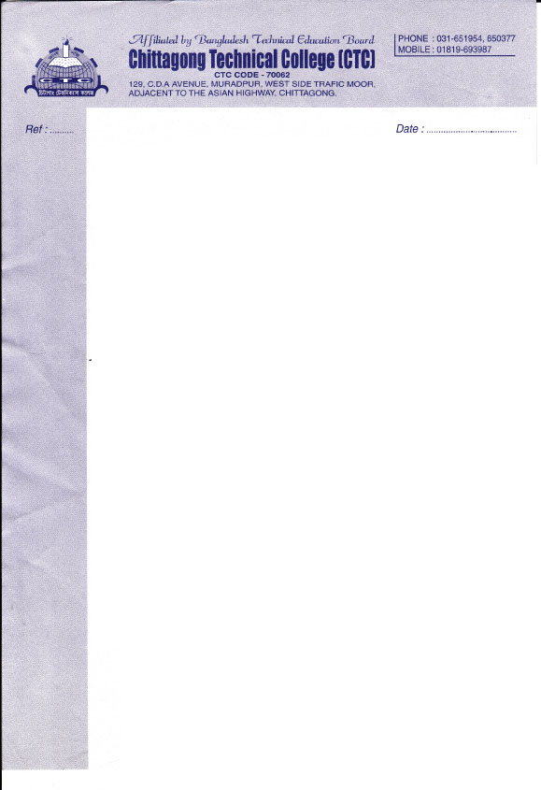

**Certificate of Experience**

This is to certify that **Mr. Sayed Md Muhim Uddin** worked in our institute from **01-04-2022** to **30-08-2023** as a **Chief Instructor** in Dept. of **Computer Science and Technology**. During his working period we found him dedicated, hardworking and sincere. He is very professional and quick learner.

We wish him good luck in his future endeavors.

K. M. Musa

Principal

Board of Trustee

Chittagong Technical College(CTC)